**TruYouTM— Skincare Truly Personalized**

Aug 1st, 2020

Luke Verdi/Jeffrey Day/Haoyu Zhang/Aditya Mengani

Peer Credit - Mackenzie Lee

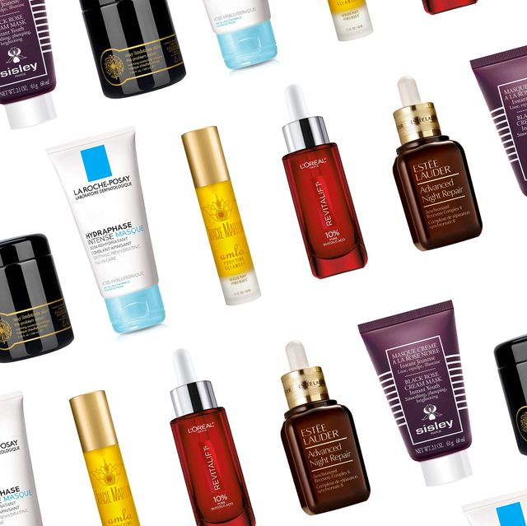

**Overview**

TruYouTM - an idea of personalized skincare service that aims to utilize face recognition technology and data science to provide ideal skincare regimens for any user. This product was recently conceived by Mackenzie Lee, Dermatologist MD.

* Intended Audience: skincare manufacturers, consumers of skincare product (13-55 year old men and women)
* Our team’s mission is to assess the performance of TruYou with regards to the accuracy of it’s skincare recommendation service.
* The goal of this project is to design and operate
  + an investigation (blinded experiment) of TruYou performance on the treatment group, with comparison to the control group (participants keep using the same or equivalent products and routine as previously used during the blinded experiment)
* The rest of the document outlines the proposed design.

**Research Question**

The primary research question to be explored is how the effectiveness of the TruYou skincare product recommendations compares to consumers’ existing regimens. The effectiveness of a skincare routine can be defined by how well the routine:

* Maintains consistent color and texture
* Prevents appearance of zits and/or blemishes
* Reduces pore size
* Normalizes pH levels of skin
* Maintains normal sebum levels

**Data**

This project will first employ the TruYou recommendation model, which was recently released. This model takes in lots of data from the users, and outputs a recommendation of what a user should use. This model uses a machine learning algorithm to generate recommended skin care products to use for each week. The model has been compared against dermatologist recommendations; however, this model has not yet been assessed with real users (the goal of the current test design).

The model takes in the following user data when they elect to participate in the TruYou program. Also included is a short explanation of why such a variable would be collected:

* Location - for climate information and highlighting possible concerns such as dry lips from cold wind or a perpetually moist face from a hot humid climate
* Background information on behaviour such as how often outside, smoker, stress, sleep, screen time, water drinking, alcohol, diet, workout routine - all of these could have different effects such as high exercise resulting in sweat or stress increasing the likelihood of breakout.
* User feedback about skin - their understanding of dry, oily, how often they breakout, etc.
* What makeup or current products being used - can give a sense of the current skin microbiome, or what the user has found to be working
* What would a user be willing to apply or how much they would be willing/able to spend on supplements - if a user isn’t going to apply a facemask or can’t afford a certain product, then it shouldn’t be recommended
* Scan of the users face - give a more detailed, unbiased description of the users skin, with details they might not know such as consistent color/texture, pH, pore size, sebum levels and number of blemishes. This scan also gives an output of overall skin health based on each of these measurements. This scanning technology was previously developed and validated by TruYou to be an accurate measure of skin health. The scans can be taken with only the users phone.

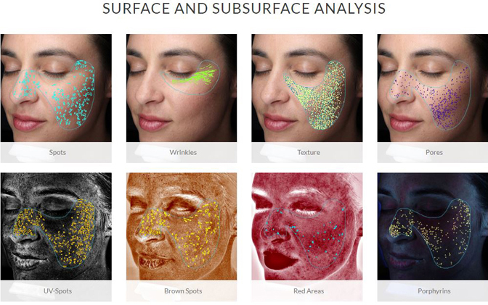

Images from: <https://www.hullderm.com/aesthetics/visia-skin-analysis/>

The TruYou recommendation model uses this input information and yields a recommendation of what products to use, when to use them, and for how long. Thus the model already contains information about what products are available to be used and how they are used. This was previously collected from extensive market research. The model generates these recommendations by using a proprietary machine learning algorithm, using neural networks and clustering methods.

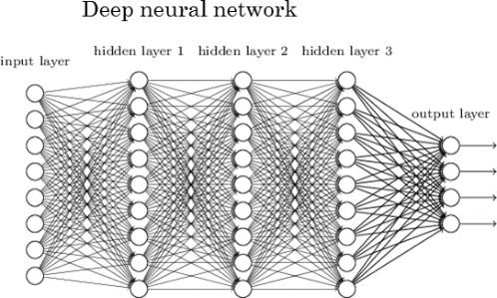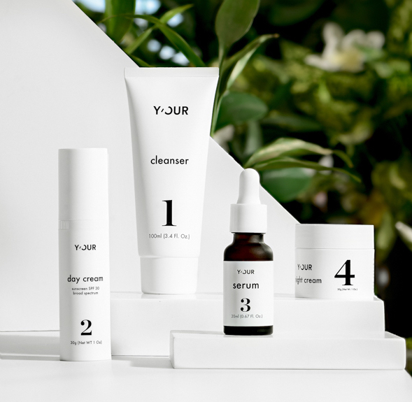

Images from: <https://www.kdnuggets.com/2020/02/deep-neural-networks.html> (left) and <https://y-ourskin.com/> (right)

Each week, additional information will be collected from the user, in the form of any updates to the background information and a new scan of the user's face. This is used to make the updated recommendation for each week of the 12 week study.

**Study Design**

* Objective: The experiment we would like to pursue is ideal to assess the causal impact of using the TruYou Skincare app in terms of accuracy on one’s skincare
* Sample: We will create a sample that is randomly sampled from the population and is representative of certain characteristics like age, wage etc.



Images from: <https://www.lchainc.org/about-us?lightbox=dataItem-irnvokmk>

* Control group: Subset of people who will be receiving TruYou recommendations, but recommendations will be for products that are functionally similar to what they are currently using. However, these users will still think that the model is recommending an optimized selection of products. This will ensure that they both receive a placebo effect, while still receiving no discernible benefit from the recommendations (this is akin to them having continued to use their same routine/products).
* Treatment group: Subset of people that will receive the actual personalized TruYou recommendations for skin and see improvements in skincare
* Data gathering: We would like to gather information from users using time-series data in real-time, detect changes in skin habits and suggest recommendations (to the treatment group) based on the scientific literature and market research.
* Duration: The study will last for 12 weeks to allow for sufficient time to see an effect. At each week of the study, both groups will have their face scanned to continue generating TruYou recommendations. Another scan will be taken at the end of the final week. This will be compared against the initial scan, to see if the treatment group was larger than the control group.

**Sample**

* Sampling frame: The sampling frame consists of all TruYou users. They are identified by a unique id which is used to retrieve the entire information related to the user from our TruYou Customer database system.

   
 Images from:<https://piwik.pro/blog/what-is-data-sampling/>

* Sampling Techniques: We will be using a probability sampling technique like Two-stage cluster sampling method for sampling.
* Two-stage cluster sampling**:** We would use probability sampling techniques like two-stage cluster sampling that balances our needs of randomness in sample and generates a sample that is representative of all elements of clusters identified using details like age, wage etc.

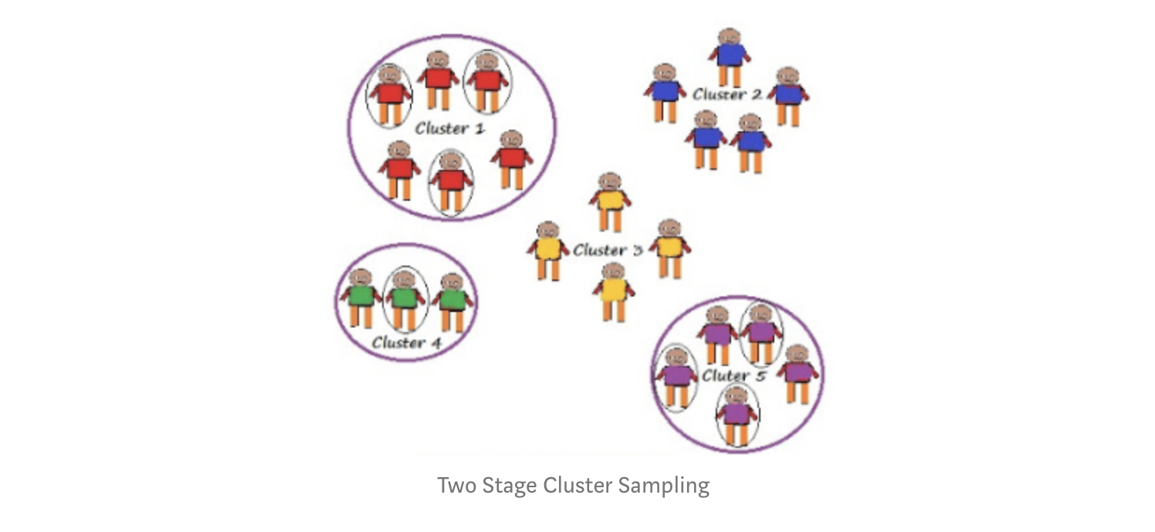

Images from:<https://towardsdatascience.com/sampling-techniques-a4e34111d808>

* Snowball sampling(If needed) : Since finding all the required volunteers for the study can be challenging, if we fall short of enrolling needed volunteers we would like to use a non-probability sampling method like snowball sampling where volunteered research participants can also refer or recruit other research participants thus achieving the preferred sample size as a worst case approach.
* Sampling size**:** Since we will not be able to study the entire population for this experiment, we would like to use a random sample size for our experiment based on some desired characteristics of accuracy needed.

For example, a sample set of 400 volunteers who would represent the entire population as a whole is created based on the below accuracy levels desired by the experiment:

* Population size(10000)
* Margin of error +/- 5 %
* Confidence Interval of 95 %
* Standard Deviation - 0.5

**Variables and/or Intervention**The key variable to be measured will be the health and appearance of a given participant’s skin over a period of time. A single measure of health will be composed of a number of quantitative measurements previously discussed in the research proposal. These include:

* Deviations from normal skin color measured as average color and size coverage area
* pH level of skin measure from 1 to 14
* Pore size measured in micrometers
* Sebum levels in micrograms per centimeter squared
* Number and size of visible blemishes

Each of these values will be measured weekly from the scan of the participant’s face. The weekly measurements will allow for a comparison of the change in skin health over time.

**Statistical Methods**

As this study desires to measure whether the TruYou recommendations have an effect on skin health, statistical methods will be employed to measure the effect size for the treatment group. This can then be compared to the effect size measured from the control group.

As mentioned above, the output from the face scans alone will be used to quantify the health of a person's skin across the measured metrics of consistent color/texture, pH, pore size, sebum levels and number of blemishes. The health of the treatment group at the end of the study will first be compared against the health of the treatment group at the beginning of the study using a paired t-test. If a difference in mean skin health is observed and is statistically significant, it is possible that the treatment is having some effect. If no difference in means is observed or if there is a decrease in mean skin health, then the treatment is likely having no effect or is harmful.

Next, the same paired t-test would be performed between the control group before and after using TruYou. It is entirely possible that this group would also see a statistically significant improvement in skin quality as well, just due to the placebo effect of having products “recommended” by an intelligent algorithm or of being more dedicated to a skincare routine due to the whole experience. Regardless, the group will be assessed for a statistically significant effect size (in a positive or negative direction) while using the products over the 12 week span.

If the TruYou treatment group shows an increase in skin health, while the control group shows a decrease, then it can be asserted that the TruYou recommendations resulted in greater health. In the event that both groups see a statistically significant improvement in skin health, the practical significance of effect sizes will be compared. In order to assert that getting real recommendations from the TruYou system improves skin health, the effect size would have to be larger than the control group.

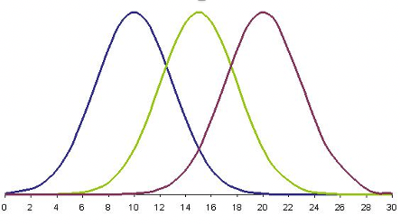

**Potential Risks**

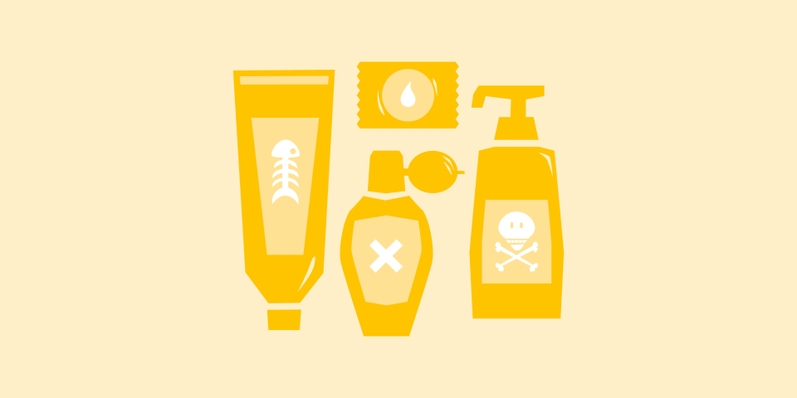

* Health & Safety
  + There are probably hidden chemical ingredients other than those claimed in skincare products. Users/experiment participants may have adverse reactions or extreme allergic reactions to these ingredients, or unknown reasons from the complexity of skin type.
    - Include potential compensation, insurance purchase in the budget plan.
    - Employ a dermatologist or medical consultant. Set up a crisis management/ customer medical service team.
    - Employ legal consultant; well-prepared agreements for the experiment participants.
    - Try the best to choose skincare products of detailed ingredients information. Acquire the chemical analysis of the recommended skincare products from reliable third party labs or by ourselves.



* Information Security Risk
  + Personal information (age, incoming level, address, etc.) will be collected for research study purposes in this project. It would be an ethical and legal disaster for the team if the private data is leaked or misused.
    - Employ cyber security team to protect the data.
    - Monitor the usage of the data including participant’s personal information within the team.

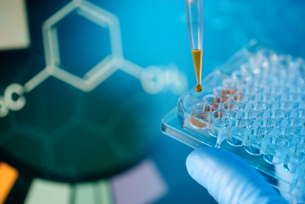

* Stakeholder Risk
  + Skin care companies which invest in this project may limit the brand choice for skincare products applied in the experiment.
  + Possible litigation related to intellectual property with skincare manufacturers. Chemical analysis may disclose patented recipes, manufacturing techniques, etc.
  + This project may be obstructed by luxury/high end skincare brands. This research study may uncover that certain extremely-profitable brands may apply unfair practices in customer relationships to benefit themselves.
    - Well-prepared agreements with the investors and collaborators to ensure our team‘s voice in decision-making.
    - Employ legal consultant in intellectual property for possible litigation.
    - Option to employ a PR team to deal with the dispute and obstacle from skincare manufactures or others.

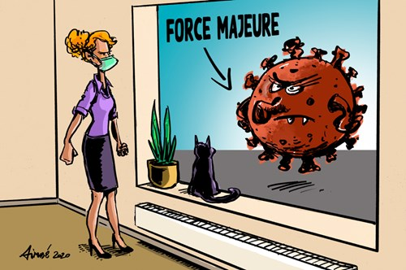

* Force Majeure
  + When an extraordinary event happens (natural disaster, pandemic, riot, war, etc.), in-site routine scan of skin condition could not be operated. Preparation and delivery of uniform packaging skincare could be delayed or unaccomplished for the blinded experiment.
    - Run the project in multiple locations (different countries, continents) in case that the whole project will be suspended by a single force majeure.
    - Application of new techniques to operate remote surveys, acquire skin scanning from taking photographs by users themselves with the aid of machine learning.

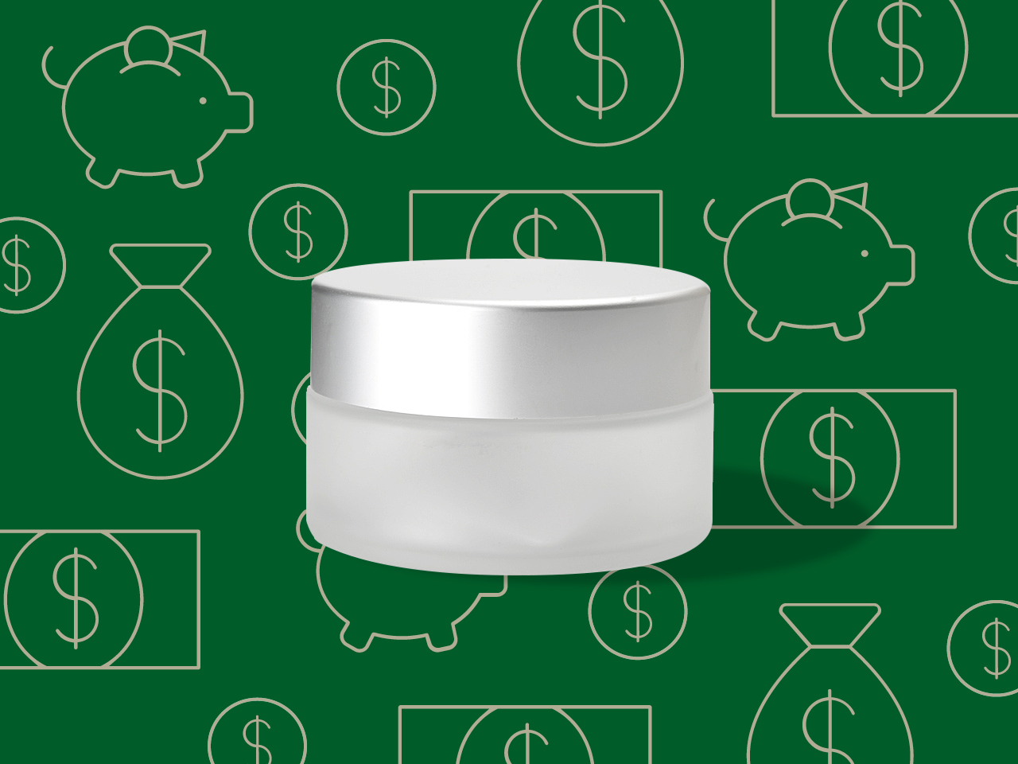

* Budget Risk
  + It takes much longer to observe obvious change for some skin conditions (e.g. scar, wrinkle, etc.). Considering the cost of skincare products supply in the long term, the budget may be insufficient to support the blinded experiments to testify the accuracy of TruYou regarding all the skin conditions.
    - Cooperate with skincare products manufacturers for free or low-cost supply.
    - Employ PR team to attract investment, raise research funding.

**Deliverables**

Below is the expected timeline of the proposed research study:

* August-September 2020 - Confirm desired sample size, sampling methodology, and research budget
* October-November 2020 - Outreach and finalization of study participants, separation into control and treatment groups
* December 2020 - Distribute study instructions and materials to participants to prepare for execution of study
* January 2021 - Collect initial skin routine and health data from participants, distribute skin routine products and instructions to treatment and control groups
* February-April 2021 - Study participants use provided products in specified routine manner, periodically providing facial scans and feedback regarding their skin condition.
* May 2021 - Gather and finalize post treatment data, perform initial data analysis
* June-July 2021 - Finalize detailed data and statistical analysis and generate both a report and slide deck presentation describing our findings as outlined in the above.